DEADLINE IS SEPTEMBER 1...DON'T MISS IT Name: ______________________________________Class of_______________________ Mailing Address: ____________________________________________________________
City, State, Zip: ____________________________________________________________
Phone: cell ______________________ home___________________________________
E-mail Address: ____________________________________________________________
❑ YES, I plan to attend THS All Alumni Reunion 2025. I have enclosed a check for the total amount made out to Trona Alumni Association.

Reunion Fees: Quantity Total
$65.00 per attendee (includes Sat lunch, Sat eve. hors d’oeuvres and
dancing to Monarch with John Young. _______ $______

Dance only - $15.00 each. May also be purchased at the dance. ______ $_____

Souvenirs (all given sizes are adult): Total Tee shirts - (White) S ______ M ______ L ______ XL______ @ $20.00 each $ ______
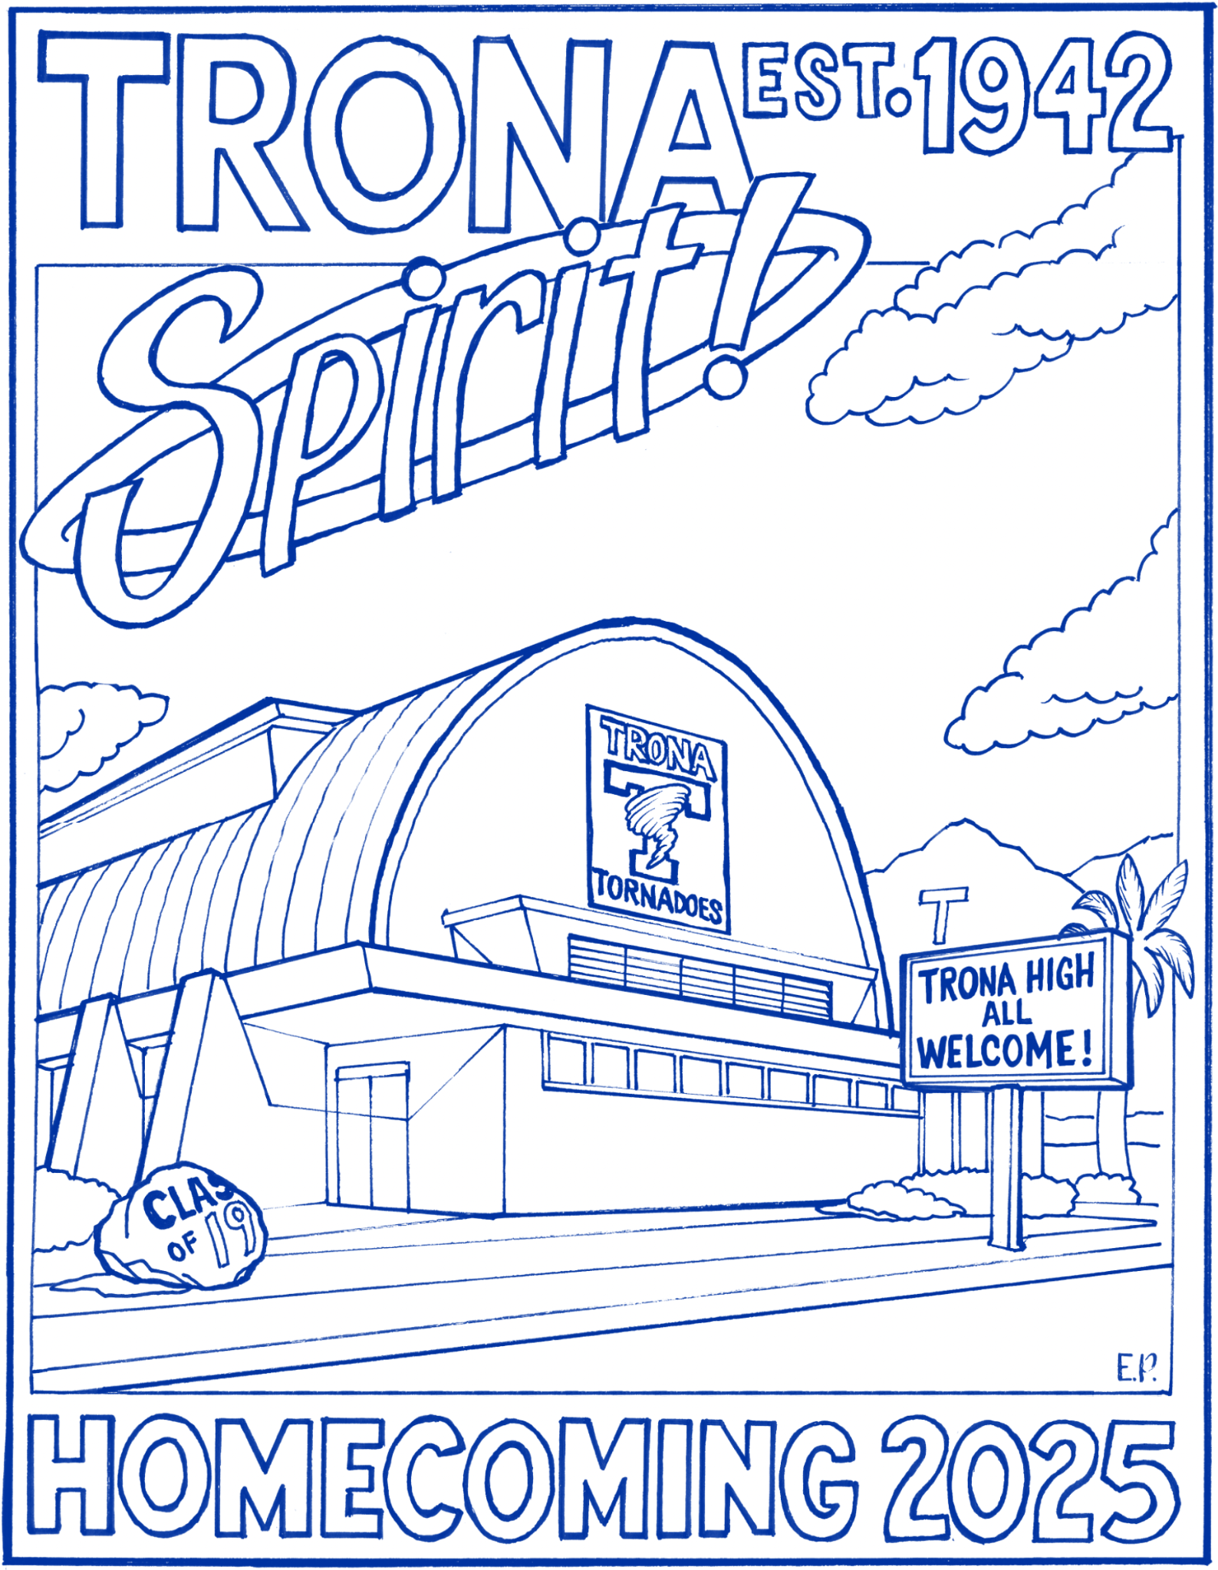
2X ______ @ $21.50 each $ ______
3X ______ @ $22.50 each $ ______
4X ______ @ $23.50 each $ ______
Zip up hoodie sweatshirts - (Blue)
S ______ M ______ L ______ XL______ @ $30.00 each $_______
2X ______ @ $31.50 each $_______
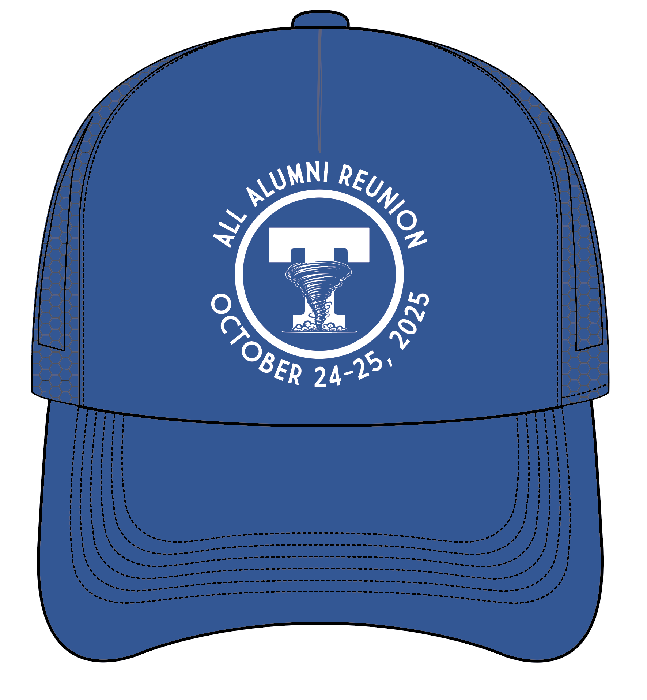
3X ______ @ $32.50 each $_______
4X ______ @ $33.50 each $_______
Baseball cap - (Velcro back) _________ @ $15.00 each $_______

TOTAL ENCLOSED $______________
❑ No, I cannot attend the reunion but would like to order the souvenirs noted above. I have enclosed a check made out to “Trona Alumni Association” for the full amount PLUS postage for each item ordered, as follows: Hat - $6.50; T-shirt - $6.50; Sweatshirt - $10.00 within CA, AZ, NV; $13.50 all other states.
_____________________________________________________________
DEADLINE IS SEPTEMBER 1...DON'T MISS IT

